# Laboratory work №3 Synchronous motor drive modelling

## Objective

The purpose of the work is to get acquainted with the modeling of actuators based on synchronous machines with permanent magnets, the modeling of brushless DC motors and the development of vector control of synchronous motors.

## Theoretical information

Next dynamic model of synchronous motor with permanent magnets is used in laboratory work:



Here:

*Rs* is resistance of stator windings;

*Ls* is stator windings inductance (special case of non-salient pole design of the motor rotor);

*Id* , *Iq*, *Ud* , *Uq* are stator winding currents and voltages along the *d*- and *q*- axes;

*J* is inertia;

Ψ*f* is flux of permanent magnets;

Ω is mechanical speed;

ω is electrical speed;

*Zp* is pole pairs;

*Tdist* is a disturbance torque.

Coordinate transformation from *dq* to *abc* coordinate system:



Coordinate transformation from *abc* to *dq* coordinate system:



It is proposed to use next formulas for calculating relative durations of opening of switches for the case of vector control:



and



where mean potential of inverter rack can be calculated by next formula:





where:

*TS –* switching commutation period;

*th*, *tl*–opening time of the upper and lower power switches in three-phase inverter rack;

γ*h,* γ*l* – the relative opening duration of the upper and lower power switches in three-phase inverter rack.

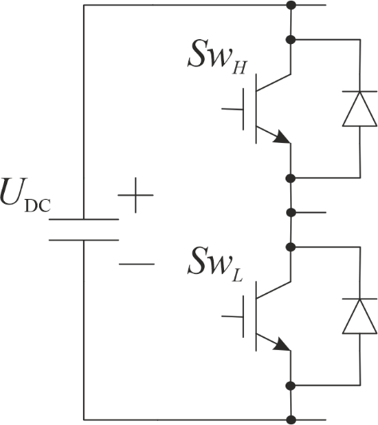

Figure 1. Rack of three-phase inverter.

Angle characteristic can be calculated for high speed ():  


Angle characteristic can be calculated for low speed ():



Use next functional diagram for vector control design:

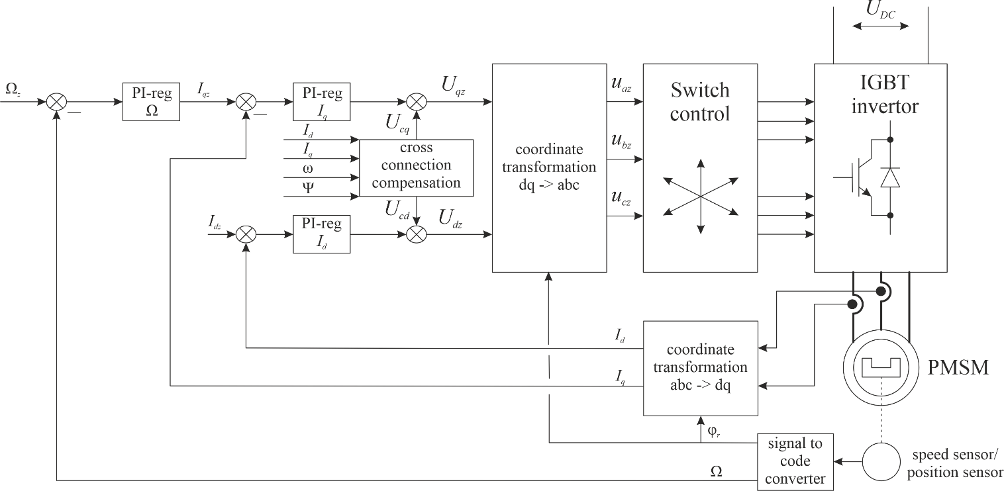

Figure 2. Functional diagram of PMSM vector control system.

Cross connection compensation can be calculated:



Use next functional diagram for brushless DC motor design:

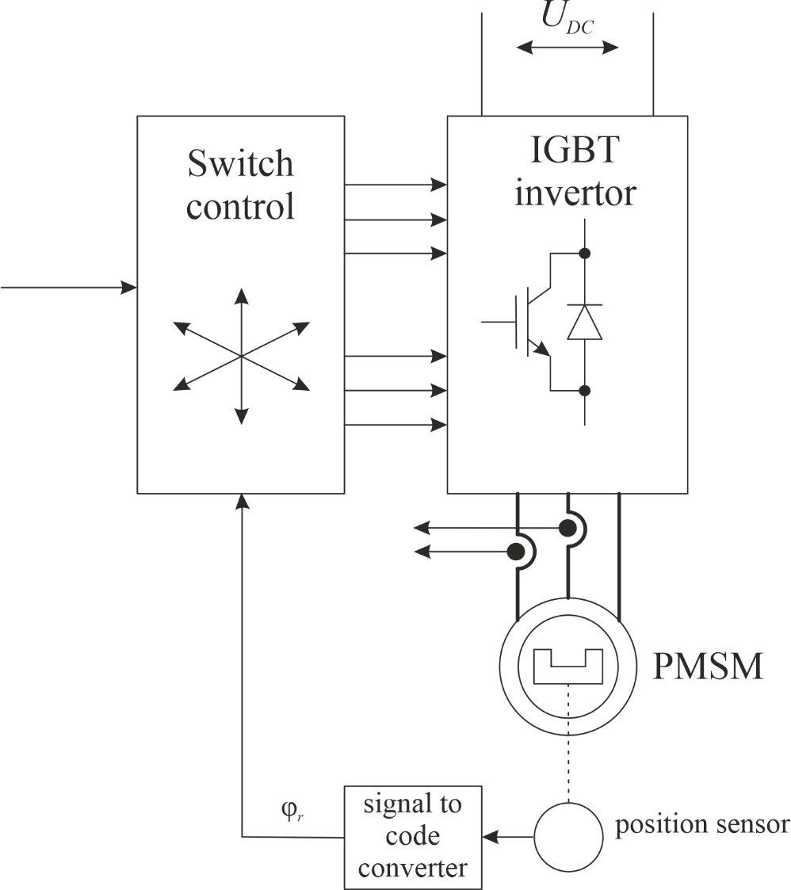

Figure 3. Functional diagram of brushless DC motor.

## The lab work task

Each variant contains data about motor parameters (*Ls*, *Rs,* Ψ*f*, *Zp*, *J*), three-phase inverter parameters (*UDC*, *Ts*).

1. Build a mathematical model of a sinusoidal pulse-width modulator in Matlab / Simulink.

2. Assemble a mathematical model of a three-phase inverter in Matlab / Simulink.

3. Assemble a mathematical model of a synchronous machine in the rotor coordinate system dq in Matlab/Simulink.

4. Assemble a brushless DC motor based on the obtained mathematical models in Matlab / Simulink. Build experimental and calculated speed/torque characteristics.

5. Create a vector control of a permanent magnet synchronous machine in Matlab/Simulink. Adjust the current loop to a linear optimum. Adjust the speed loop to symmetrical optimum.

## Report content

1. Simulation schemes.
2. Angle characteristic of PMSM.
3. Speed/torque characteristic of brushless DC.
4. Calculation of parameters of regulators for point 6.
5. Transient processes for current and speed loop (Vector control).
6. Conclusions.